Joel Sivanish
Professor Thurston
Lab 9
12/06/2025
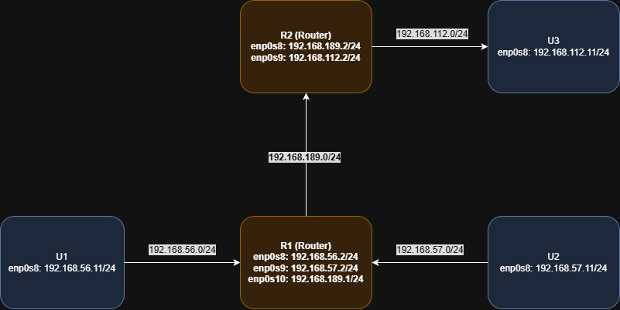
Network Topology Diagram:

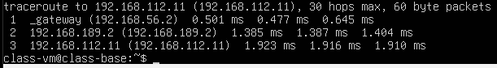
Traceroute From U1 to U3:

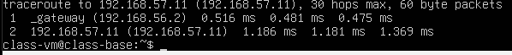
Traceroute From U1 to U2

MAC Traversal From U1 to U3:
Hop | Network | Source MAC | Destination MAC | Devices
1 | 192.168.56.0/24 | 08:00:27:d2:7f:f4 | 08:00:27:44:99:e9 | U1 → R1
2 | 192.168.189.0/24 | 08:00:27:d8:af:a9 | 08:00:27:20:11:59 | R1 → R2
3 | 192.168.112.0/24 | 08:00:27:1c:97:7c | 08:00:27:a4:96:b5 | R2 → U3
- PCAP was captured on R1 for path from U1 toU3
To determine the correct MAC addresses:
- I used ip -br link on each host to identify the MAC address of every interface.
- I then matched each interface to its subnet based on the topology.
- Since routers forward frames only to the next hop on the same LAN, each hop uses:
  - Source MAC = the router’s outgoing interface MAC
  - Destination MAC = the next hop router or host’s interface MAC
This gives the following complete path:
- U1 sends the packet to R1 → uses U1 MAC → R1 MAC
- R1 forwards to R2 → uses R1 MAC → R2 MAC
- R2 forwards to U3 → uses R2 MAC → U3 MAC
U1:
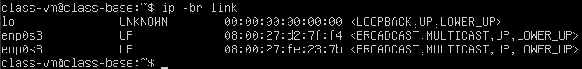
U2:
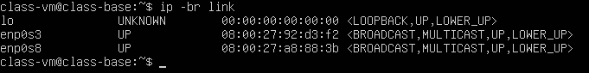
U3:
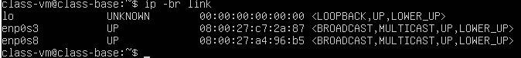
R1:
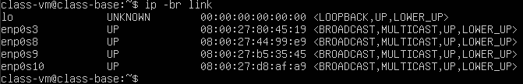
R2:
